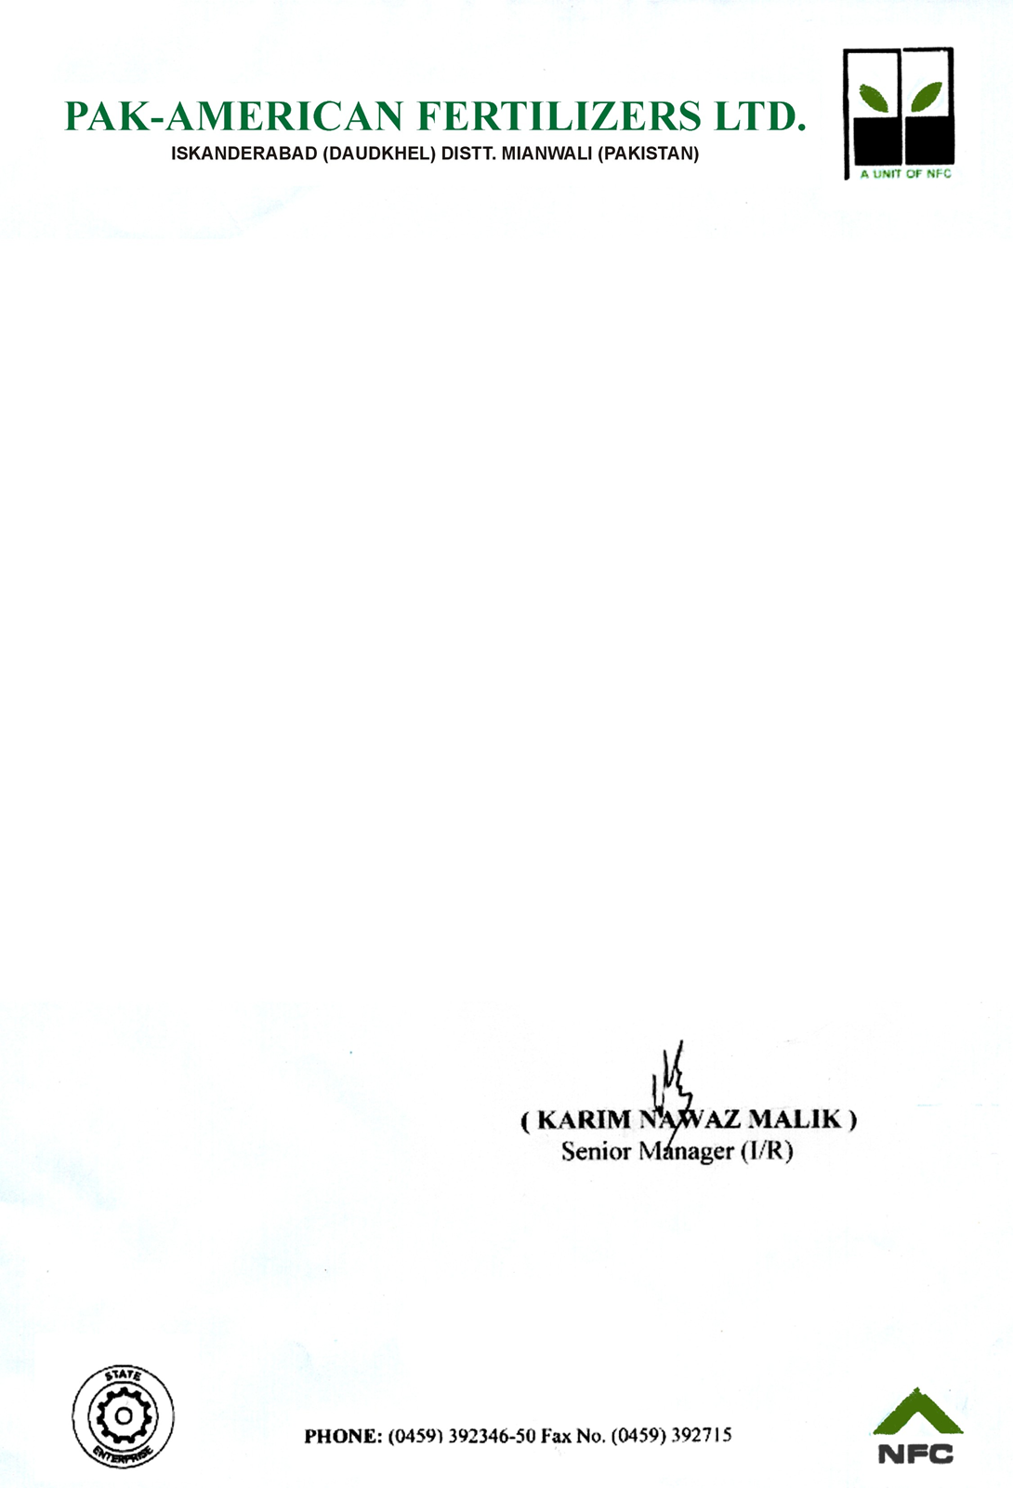

**EXPERIENCE CERTIFICATE**

It is certify that Mr. <Name> S/O Mr. <fname> work with us as <Designation> from <From2> to <To2>.

He proves his self to be right man for the post technician. During his working period we found very Hardworking, Co-operative, Honest and Dutiful in his Job. He is very obedient and hardworking person.

We wish him success in his future life.

